CSC 3210

Computer Organization and Programming

Lab 8

Answer Sheet

Student Name: Tracy Michaels

Section: 018

Lab 8(a)

Debug through each line of instructions.

Take screenshot that includes code and register window.

Record the register content.

and explain the register contents.

Line number:

Instruction: mov esi, OFFSET myBytes

Register values: ESI = 00CD4000

Screenshot: 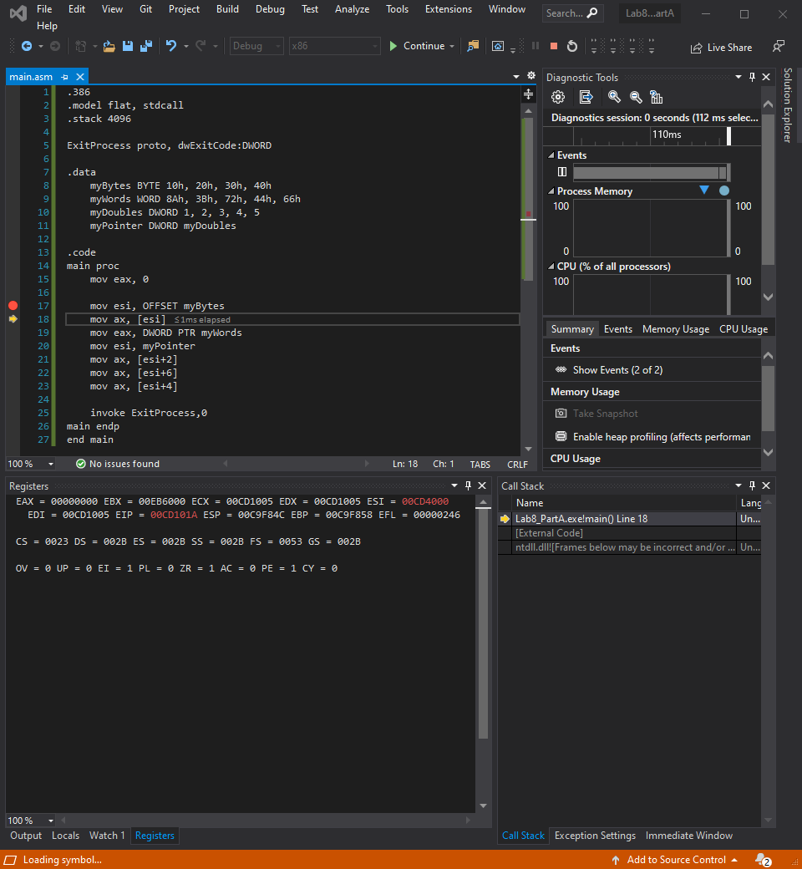

Explanation: this line takes the memory address of the beginning of myBytes and stores it in the ESI register

Line number: 18

Instruction: mov ax, [esi]

Register values: EAX = 00002010

Screenshot: 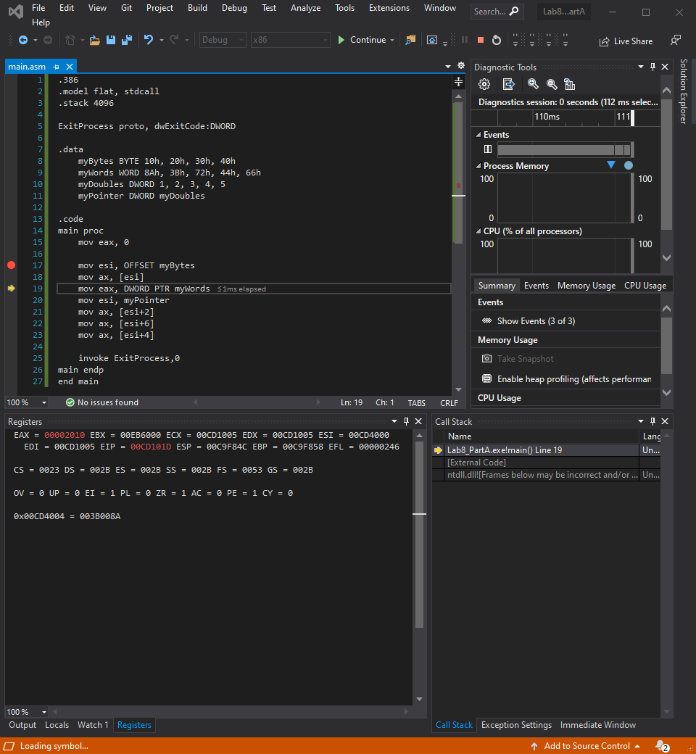

Explanation: moves the values that are stored in the location that esi is pointing to. In this case since it’s storing values in only ax it takes the first 2 values of the myBytes array and stores them in little endian order

Line number: 19

Instruction: mov DWORD PTR myWords

Register values: EAX = 003B008A

Screenshot: 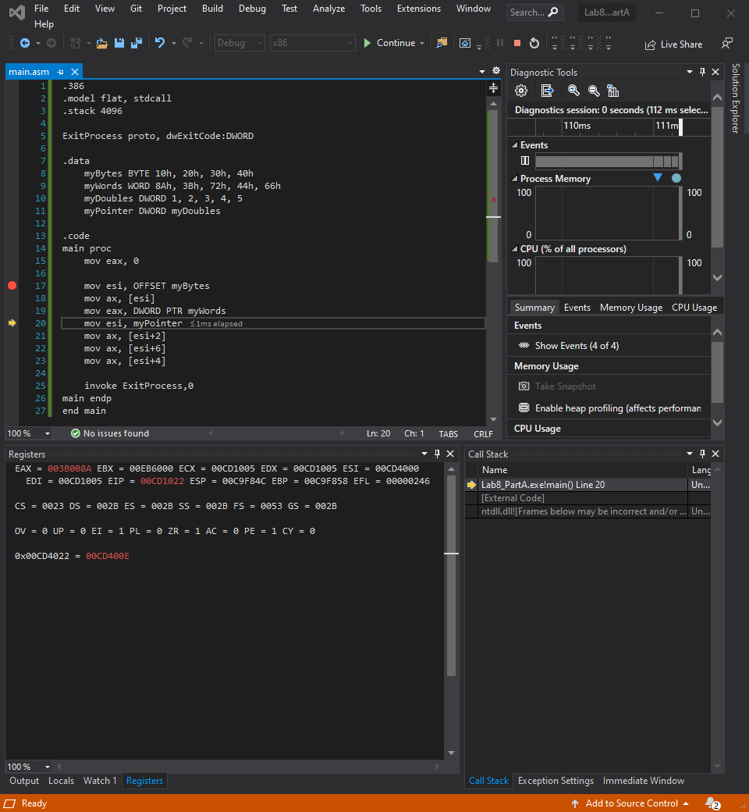

Explanation: this moves the contents stored in myWords to the eax register written as DWORDs instead of their original WORDs and stores it in little endian order and padded with 0s, only moves the first 2 elements from beginning of array since that is all that eax can hold

Line number: 20

Instruction: mov esi, myPointer

Register values: ESI = 00CD400E

Screenshot: 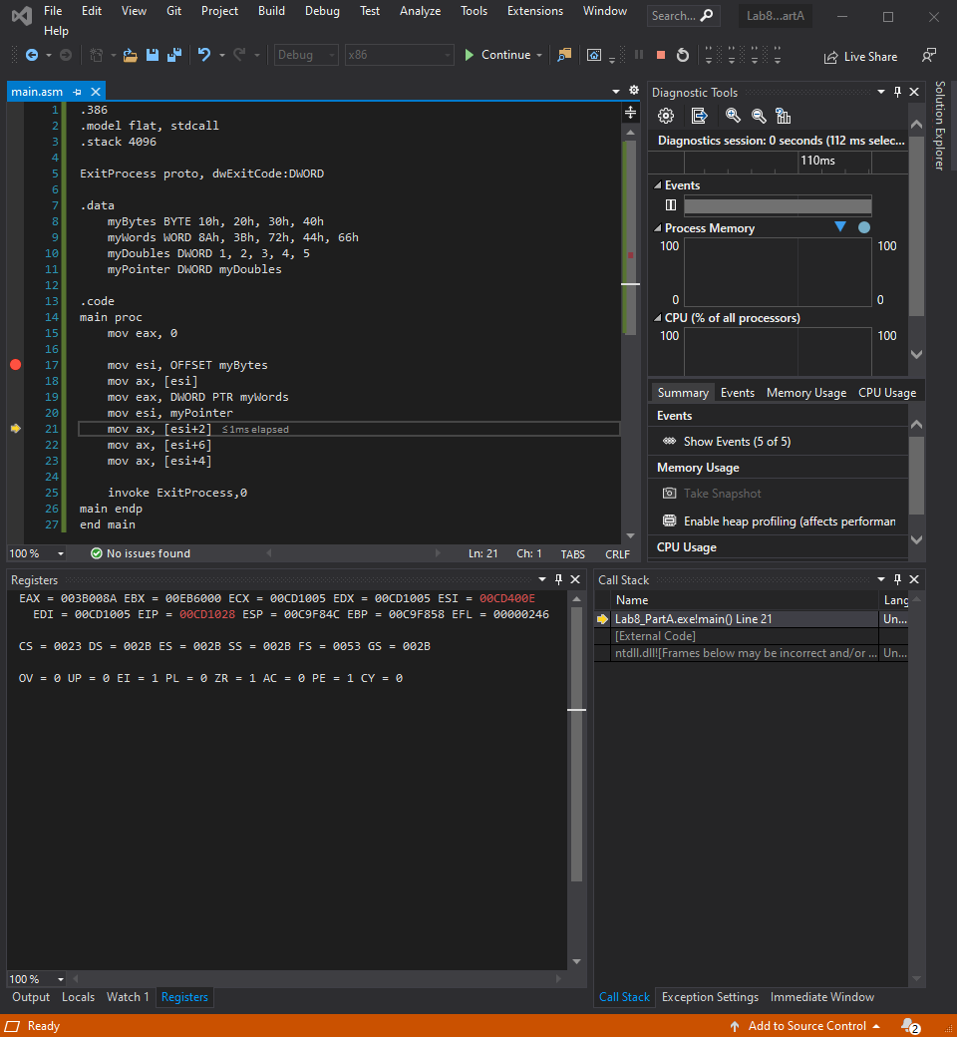

Explanation: this moves the contents of myPointer into the esi register. myPointer contained the memory location of myDoubles.

Line number: 21

Instruction: mov ax, [esi+2]

Register values: EAX = 003B0000

Screenshot: 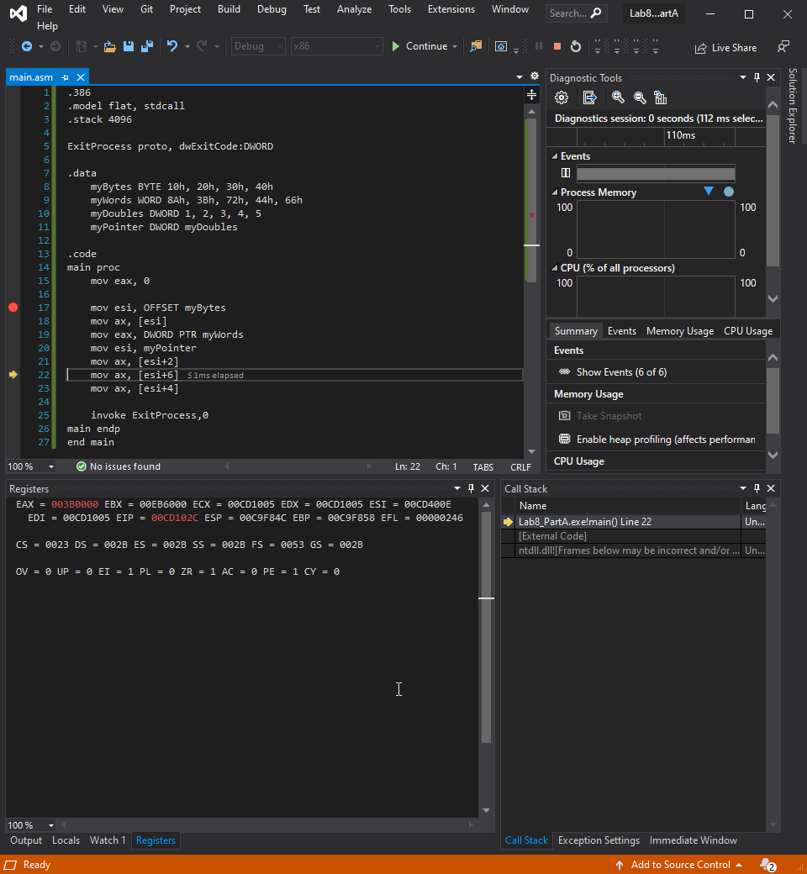

Explanation: this moves the contents stored in memory address stored in esi register incremented by 2 bytes, which in this case is half way into the first element of myPointer.

Line number: 22

Instruction: mov ax, [esi+6]

Register values: EAX = 003B0000 no change

Screenshot: 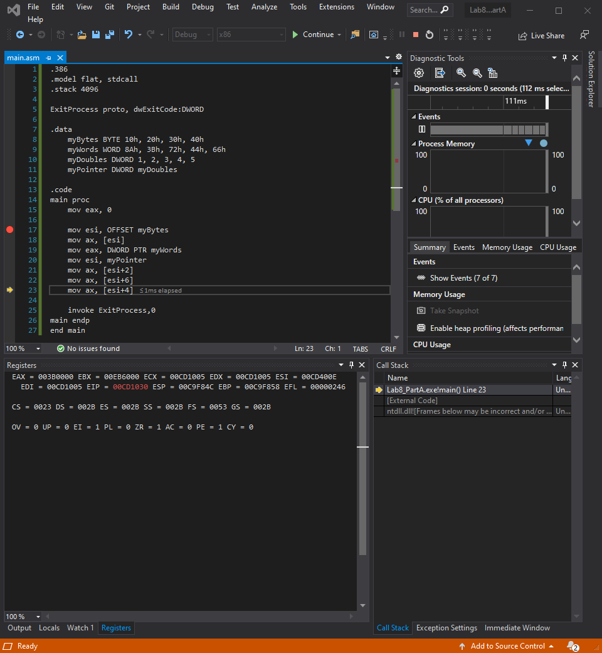

Explanation: there was no change in the value of EAX since the it is starting again halfway though the second element of myDoubles

Line number: 23

Instruction: mov ax, [esi+4]

Register values: EAX = 003B0002

Screenshot: 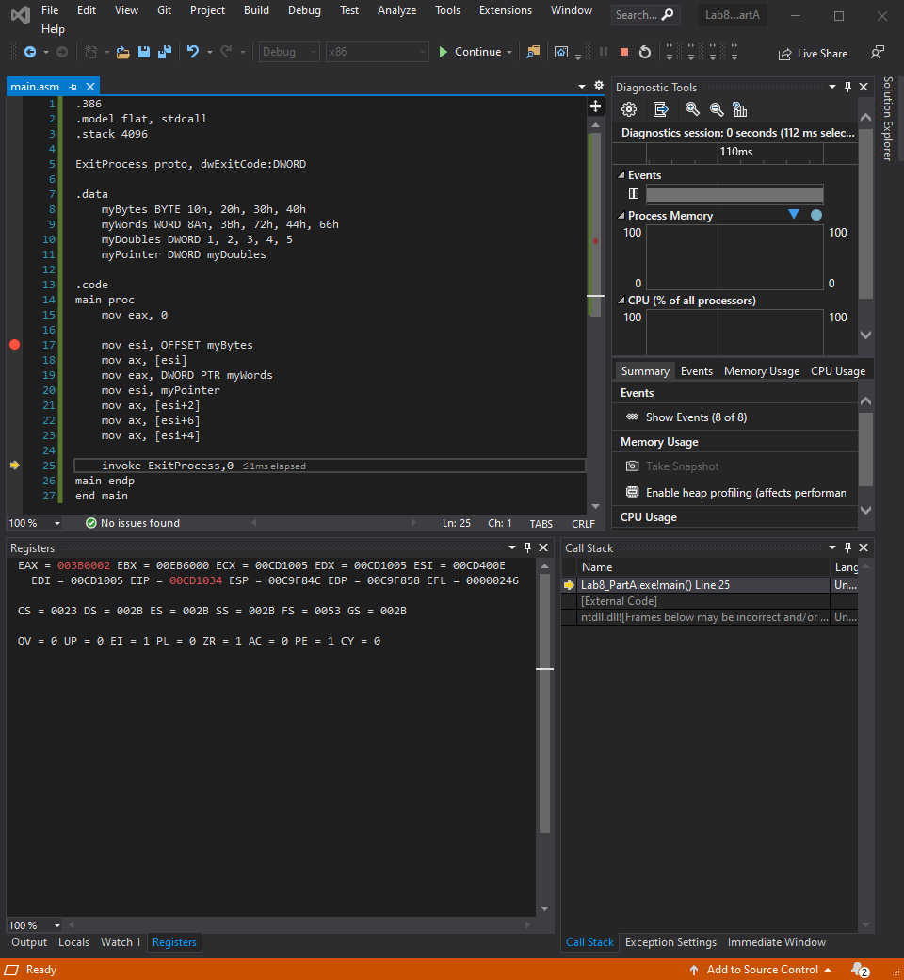

Explanation: now that the start of the second element of the myDoubles array have been stated the value of the ax portion of the eax register now contain the value that is stored in the second element of myDoubles array which is decimal 2

Lab 8(b)

Debug through each line of instructions.

Take screenshot that includes code and register window.

Record the register content.

and explain the register contents.

Line number:

Instruction:

Register values:

Screenshot:

Explanation:

Line number:

Instruction:

Register values:

Screenshot:

Explanation:

Line number:

Instruction:

Register values:

Screenshot:

Explanation:

(Copy this format as needed)

Lab 8(c)

Debug through each line of instructions.

Take screenshot that includes code and register window.

Record the register content.

and explain the register contents.

Line number:

Instruction:

Register / variable content:

Screenshot:

Explanation:

Line number:

Instruction:

Register / variable content:

Screenshot:

Explanation:

(Copy this format as needed)

Lab 8(d)

Debug through each line of instructions.

Take screenshot that includes code and register window.

Record the register content.

and explain the register contents.

Line number:

Instruction:

Register values:

Screenshot:

Explanation:

Line number:

Instruction:

Register values:

Screenshot:

Explanation:

(Copy this format as needed)